# AACC-72[CRNT-40076]: Can only import maximum of 100 entites (BO's instance) in one go

## MAIN

Entities🡪Import

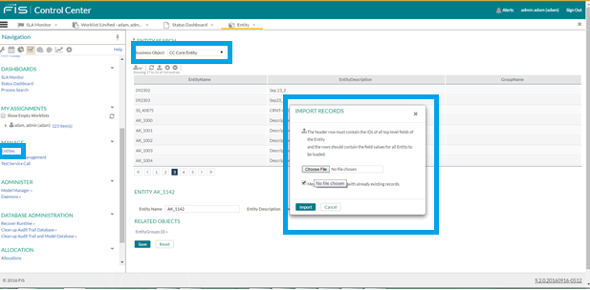

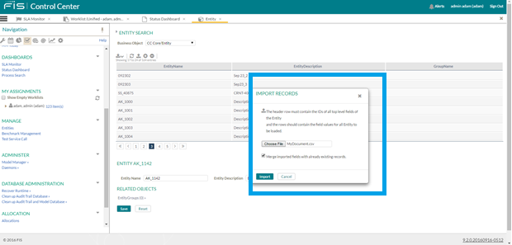

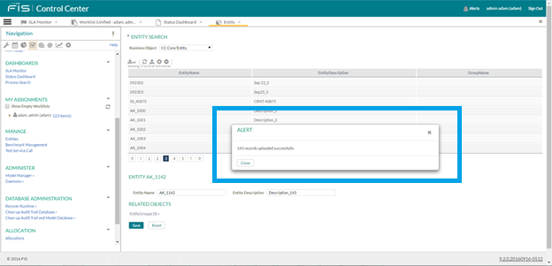

Uploaded Document :



When uploading using the group name also for 1000 records with group name as crossover.

